1. Get all countries – Api call

1. Query country by name – Api call

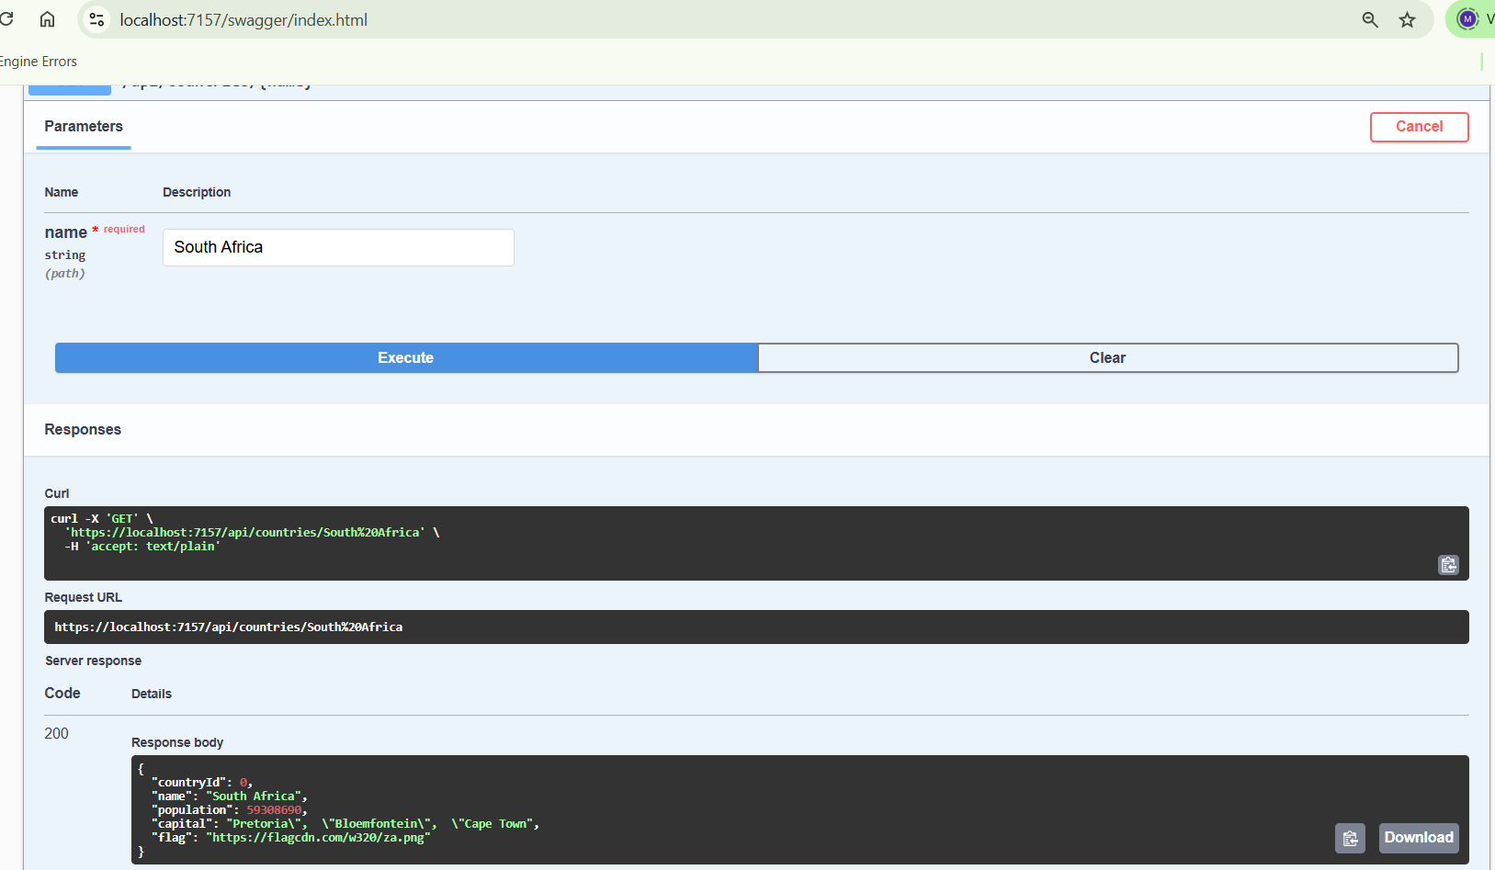

1. Front End – Home Screen

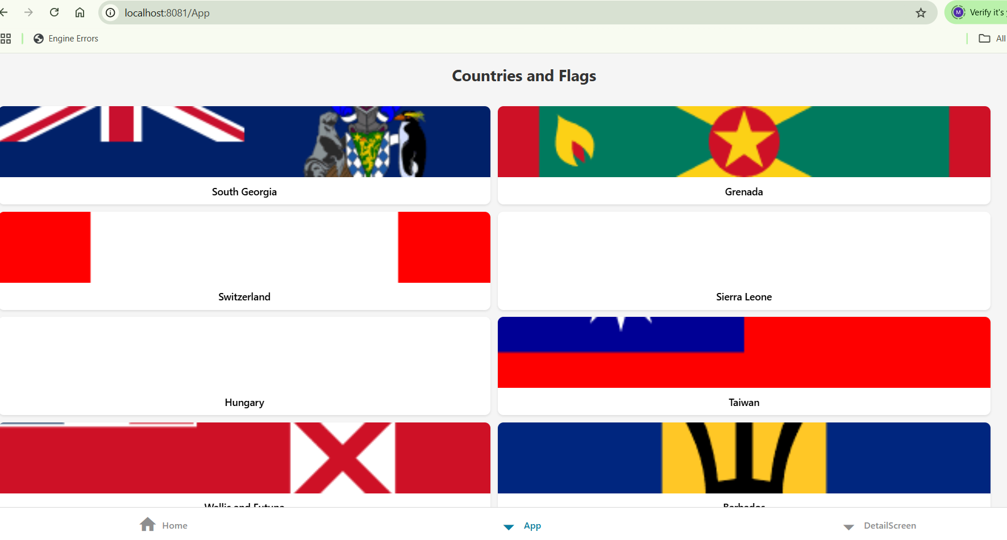

1. Detail Screen for Switzerland

